
EE 1004 & CSE 2062
OBJECT-ORIENTED PROGRAMMING

PROJECT #1 REPORT

Team Members
 | Name Surname | Contribution Details
1 | Feyzullah Oğuz 150720035 | Question 2, project report
2 | Yunus Emre Turunç 150721854 | Question 3, project report
3 | Ebubekir Mutugan 150720002 | Question 4, project report
4 | Mehmet Akif Türkmenoğlu 150720061 | Question 3 and 4, project report

Spring 2024
Table of Contents
Part #1 3
1.1 Brief explanation of the problem 3
1.2 UML Diagram 3
1.3 Data field definition List 3
1.4 Object definition List 3
1.5 Method definition List 3
1.6 Screenshots of the sequence 3
1.7 Extra features 3
Part #2 4
2.1 Brief explanation of the problem 4
2.2 UML Diagram 4
2.3 Data field definition List 4
2.4 Object definition List 4
2.5 Method definition List 4
2.6 Screenshots of the sequence 4
2.7 Extra features 4
Part #3 5
3.1 Brief explanation of the problem 5
3.2 UML Diagram 5
3.3 Data field definition List 5
3.4 Object definition List 5
3.5 Method definition List 5
3.6 Screenshots of the sequence 5
3.7 Extra features 5
REFERENCES 6

Part #1

Brief explanation of the problem
The game prompts a player to guess a 4-digit number in the first stage and a 5-digit number in the second stage. After each guess the game provides feedback indicating the correct digits and their positions. The player has a limited number of guesses in each stage. If the player successfully guesses the number within the allowed number of attempts,they progress to the next stage. The game continues until the player either completes both stages successfully or runs out of guesses.

1.2 UML Diagram

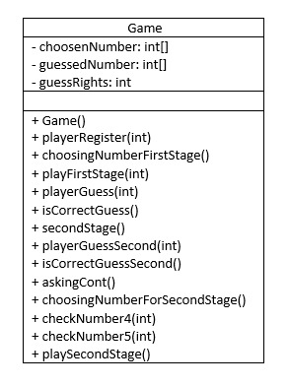

1.3 Data field definition List
List all the variables you defined. Also briefly comment on their purposes.
# | Modifier | Type | Name | Comment
1 | private | int | ChoosenNumber | an integer array stores the digits of the number chosen by the user
2 | private | int | guessedNumber | an integer array stores the digits of the number guessed by the user
3 | private | int | guessRights | an integer variable to keep track of the number of guess rights remaining for the player

1.4 Object definition List
List all the constructors you defined. Also briefly comment on their purposes.
# | Name | Args | Comment
1 | Game | () | initializes the game state at the beginning, providing default values for the game variables necessary for the game

1.5 Method definition List
List all the methods you defined. Also briefly comment on their purpose.
# | Modifier | Return Type | Name | Args | Comment
1 | public | void | playerRegister | (int playerID)
2 | public | void | choosingNumberFirstStage
3 | private | boolean | checkNumber4 | (int number)
4 | public | void | playFirstStage | (int playerId)
5 | private | void | playerGuess | (int guess)
6 | private | boolean | isCorrectGuess
7 | public | void | secondStage
8 | private | void | playerGuessSecond | (int guess)
9 | private | boolean | isCorrectGuessSecond
10 | public | boolean | askingCont
11 | public | void | choosingNumberForSecondStage
12 | private | boolean | checkNumber5 | (int number)
13 | public | void | playSecondStage

1.6 Screenshots of the sequence
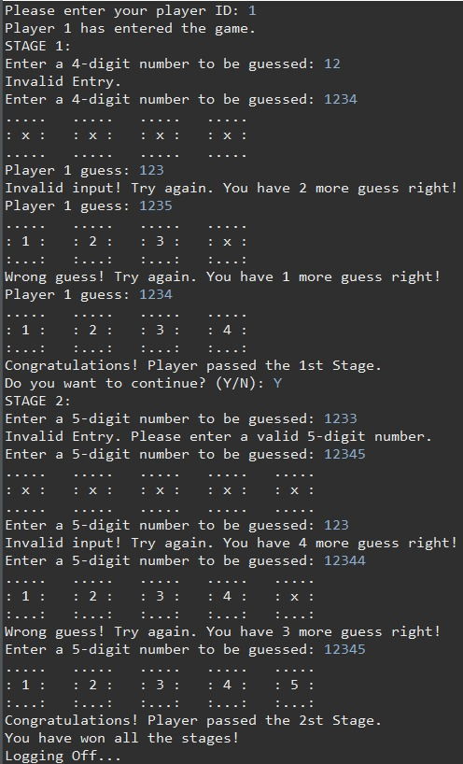

1.7 Extra features
- We have no extra features.

Part #2

2.1 Brief explanation of the problem

The task is to identify and list all "Ultra Magic Numbers" (UMNs) in a given range from 100 to N; where N is a positive integer entered by the user. UMNs are defined as numbers that are the same when read from beginning to end, have no repeating digits, and consist of more than two digits. UMN examples include 202, 423324, and 818; but numbers like 333 or 11111 are not suitable. The program should print all UMNs in the range, display a message for invalid entries (negative numbers or numbers less than 100), and count how many UMNs are in the given range.

2.2 UML Diagram

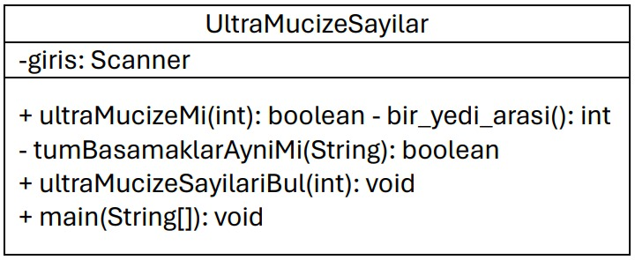

2.3 Data field definition List
List all the variables you defined. Also briefly comment on their purposes.
# | Modifier | Type | Name | Comment
1 | public | int | N | value of upper bound point that user need to enter

2.4 Object definition List
List all the constructors you defined. Also briefly comment on their purposes.
# | Name | Args | Comment
1 | UltraMucizeSayilar | () | İnitializes the find ultra magic numbers that we define as the name of the object

2.5 Method definition List
List all the methods you defined. Also briefly comment on their purpose.
# | Modifier | Return Type | Name | Args | Comment
1 | public | static boolean | ultraMucizeMi | (int sayi)
2 | private | static boolean | tumBasamaklarAyniMi | (String sayiStr)
3 | public | static void | ultraMucizeSayilariBul | (int N)
4 | public | static void | main | (String[] args)

2.6 Screenshots of the sequence
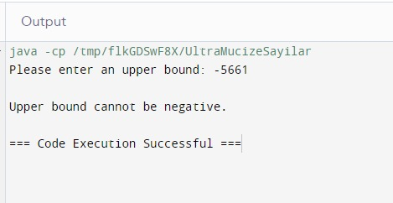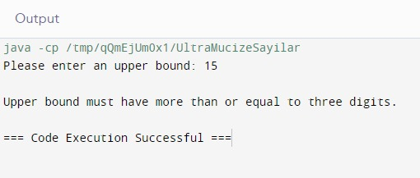
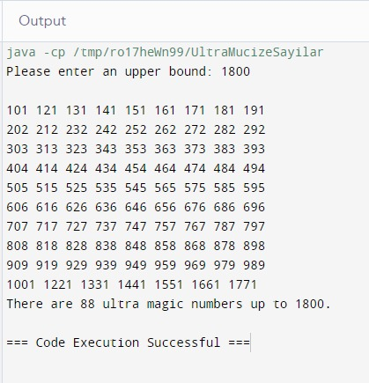
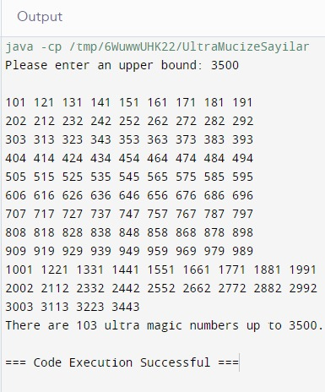

2.7 Extra features
- We have no extra futures.

Part #3

3.1 Brief explanation of the problem

This Java program prompts the user for various inputs related to their personal information (e.g. birthday, first letter of name, etc.) and performs calculations based on these inputs (e.g., calculating powers, calculating prime numbers, determining Fibonacci numbers). Finally the user is asked to solve a multiplication problem. If the user's answer is incorrect, the program will ask the user to try again until the correct answer is given. The goal is for users to find numeric codes based on their input and calculations. The program uses loops and conditional statements to validate user input and ensure correct answers.

3.2 UML Diagram

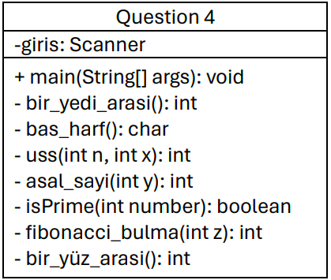

3.3 Data field definition List
List all the variables you defined. Also briefly comment on their purposes.
# | Modifier | Type | Name | Comment
1 | public | int | x | Stores values ​​between one and seven
2 | public | char | harf | Stores the initial of the name
3 | public | int | ascii | Stores the Ascii code of the letter
4 | public | int | power | Stores the Xth power of the ascii value
5 | public | int | asal | Stores the number of prime numbers up to the power value
6 | public | int | fib | Stores the value of the (asal)th element in the Fibonacci series
7 | public | int | age | Stores a value between one and one hundred
8 | public | int | code | Stores the value of the product of fib and age values

3.4 Object definition List
List all the constructors you defined. Also briefly comment on their purposes.
# | Name | Args | Comment
1 | Main | String[] args | Performs the desired steps using functions
2
3

3.5 Method definition List
List all the methods you defined. Also briefly comment on their purpose.
# | Modifier | Return Type | Name | Args | Comment
1 | private | int | bir_yedi_arasi | İnt day | Checks that a number between one and seven is selected
2 | private | char | bas_harf | String input | Checks that there is only one letter
3 | private | int | uss | int n,  int x | Takes two numbers and takes them to the power
4 | private | int | asal_sayi | int y | Finds the number of prime numbers
5 | private | boolean | isPrime | int number | Check if it is a prime number
6 | private | int | fibonacci_bulma | int z | Finds the desired fibonacci number
7 | private | int | bir_yüz_arasi | int age | Checks if there is a number between one and one hundred.

3.6 Screenshots of the sequence
Insert some screenshots of the outputs of your working project with different test cases.
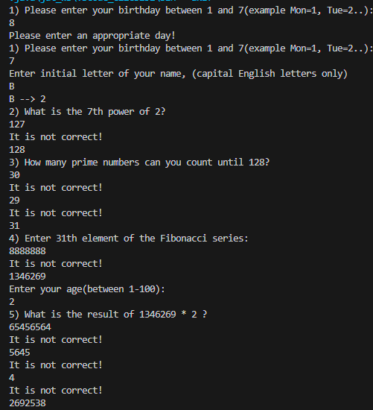
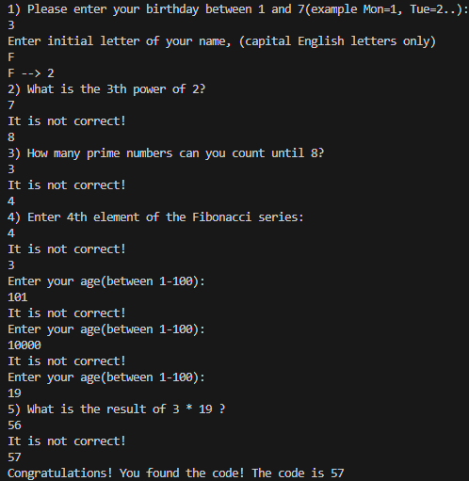

3.7 Extra features
If you have added any extra feature to your project, briefly explain what you did with bulleted items. Support with screenshots if available.
- In the first question, we obtained a more stable working code by checking not only whether the input value received is a number, but also whether the input entered is a number.

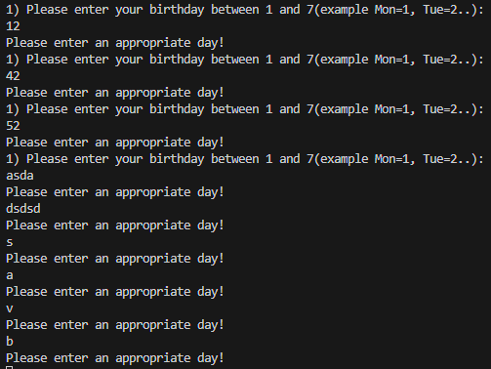

- In the second question, I took the entered value not only as a char but also as a String. Then, I reduced the risk of getting an error by checking whether the input was a number, a letter entered more than once, or a single letter.
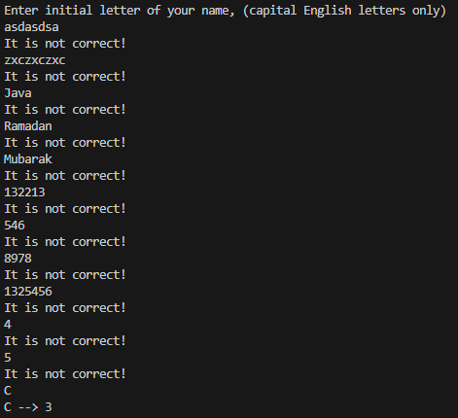

REFERENCES

- https://stackoverflow.com/questions/20961074/exception-in-thread-main-java-lang-error-unresolved-compilation-problems Ref 2
- https://stackoverflow.com/questions/45743779/visual-studio-code-java-import-errors-and-more
- https://codegym.cc/tr/groups/posts/tr.108.javada-coklu-kullanm
- https://academy.patika.dev/courses/java101/switch-case
- https://stackoverflow.com/questions/12519335/resource-leak-in-is-never-closed
- https://erhanduman.blogspot.com/2009/02/fibonacci-dizisinin-ilk-1000-terimi.html
- https://academy.patika.dev/courses/javascript
- https://codegym.cc/tr/groups/posts/tr.683.java-isdigit-yontemi
- http://onlinesorular.com/moodle/my/

